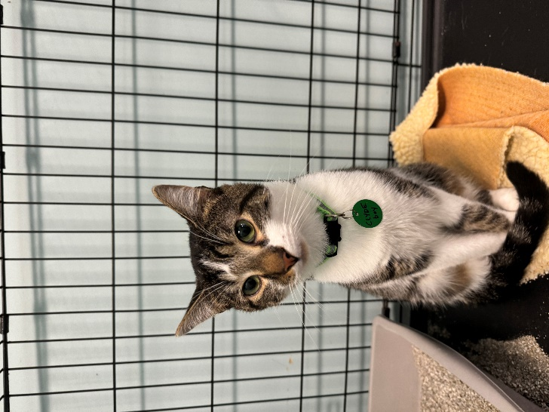NAME: Clyde

GENDER: Male

DATE OF BIRTH: June 21, 2023

FUR LENGTH: Short

COLOR: Grey and white tabby

**Purrsonality:** Clyde is a friendly young boy that likes other cats and wants to play with them. He enjoys the company of people and previously could be found hanging out with three children living in his previous home. He likes to be petted on his own time and will give signals that he doesn’t want to be petted if approached and not in the mood. Clyde makes anything into a toy and likes playing with balls, springs, and catnip mice.

**Children?** Clyde should do well with kids of all ages.

**Other cats?** Clyde would do well with other cats and would probably do best with another cat buddy.

**Dogs?** Clyde previously lived with a senior Staffordshire terrier dog and should do well with friendly dogs after proper introductions.

**Background:** Clyde was put outside as a kitten by a neighbor with many cats, and with their permission was made a pet by his former owner’s daughter. His new human dad then married a policewoman with a canine partner and several other dogs, and Clyde was restricted to the basement. The family made the decision to turn him over to a rescue where he could have the chance to live a fuller life than what they could offer.

**Medical or special care notes:** Clyde has had vaccinations for rabies and distemper, is microchipped, and has been neutered. He has tested negative for FeLV and FIV. He is eating Fancy Feast classic pate and Purina One kibble.